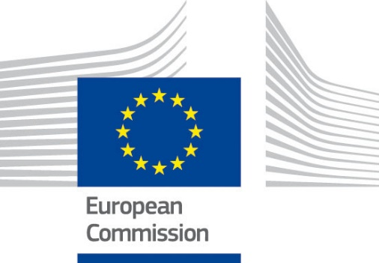

TAIEX SRSP Workshop on
E-Mobility and public charging infrastructure
organised in co-operation with
The Directorate General for Structural Reform Support
and
Ministry of Energy, Commerce and Industry

27 January 2021, 16:30-19:00 ΕΕΤ
Video Tele Conference

Beneficiary:
Cyprus

SRSP 80409

Organised and funded by the
Technical Assistance and Information Exchange Instrument
of the European Commission
Aim of the Workshop:
The Structural Reform Support Programme (SRSP) is operated by the European Commission’s Directorate General for Structural Reform Support (DG REFORM). TAIEX SRSP events are organised by DG NEAR in agreement with DG REFORM for the benefit of Member States who are receiving technical support through the SRSP.
The Webinar, which focuses mainly on policy makers and stakeholders in the field of electromobility, will concentrate on European and International Best Practice examples. Among the issues to be discussed are the different models of regulation of electromobility (e.g., licensing vs. concession models), the options available to ensure interoperability, roaming between service providers and information and technology support structures that need to be developed around recharging points.

Speakers:
- Mr Charalambos ROUSOS
Director of Energy Service, Ministry of Energy, Commerce & Industry of the Republic of Cyprus
- Mr Kaspar RICHTER
Head of Unit, B3 Sustainable Growth & Business Environment, DG REFORM, European Commission
- Mr Axel VOLKERY
Team Leader,Unit B4 ‘Sustainable & Intelligent Transport’, DG MOVE,
European Commission
- Ms Sabine CROME
Policy Officer, Unit B3 ‘Retail markets, consumers and local initiatives’, DG ENER,
European Commission
- Mr Sølve SONDBØ
Head of section for Green growth, climate and energy, Vestland County, Norway
- Mr Noel CRISOSTOMO
Air Pollution Specialist, Fuels and Transportation Division
California Energy Commission, USA
- Mr Ferran ROSA GASPAR
Manager of the Balearic Energy Institute, Balearic islands’ government, Spain
- Mr Michele BENINI
Director of the Energy Systems Development Department,
Research on the Energy System - RSE S.p.A, Italy
- Mr Jan WEGENER
Programme Manager Europe
NOW GmbH (National Organisation Hydrogen and Fuel Cell Technology), Germany

Data Protection: Personal data contained in this document is processed in accordance with the privacy statement of the TAIEX instrument in compliance with Regulation (EU) 2018/1725. The chairperson should inform all persons attending the event that photographs/pictures should only be taken during a set period of time to allow for persons who do not agree to have their photographs taken to leave the room, unless all of the participants have provided their express consent to having their photograph taken.
See https://ec.europa.eu/neighbourhood-enlargement/sites/near/files/taiex_privacy_statement_online.pdf

Please note that the timings reflected in the agenda are Eastern European Time (EET)

Wednesday 27 January 2021
Chair: Mr Michele BENINI, Director of the Energy Systems Development Department at the Research on the Energy System - RSE S.p.A
Webinar
16:30 EET | Open the channel of the IT platform for the participants and speakers to connect. Event starts /technical introduction/solving participants’ issues  Registration of participants
16:45 | Short introduction and instructions on the technical aspects (how this webinar works, how it is structured, how to communicate)
 | Welcome address
17:00 | Mr Charalambos ROUSOS, Director of Energy Service, Ministry of Energy, Commerce & Industry of the Republic of Cyprus  Mr Kaspar RICHTER, Head of Unit, B3 Sustainable Growth &Business Environment, DG REFORM, European Commission
 | The European e-mobility strategy
17:10 | The announced revision of AFID and its focus in terms of recharging infrastructure  Speaker: Mr Axel VOLKERY, Unit B4 “Sustainable & Intelligent Transport”, DG MOVE, European Commission
17:20 | Efficient integration of e-mobility into the electricity system - the Clean Energy Package  Speaker: Ms Sabine CROME, Policy Officer, Unit B3 “Retail markets, consumers and local initiatives”, DG ENER, European Commission
 | Past and current experiences on electric recharging infrastructure
17:30 | How Vestland county contributes to the electric car-revolution  Speaker: Mr Sølve SONDBØ, Head of section for Green growth, Climate and Energy, Vestland County, Norway
17:45 | California 2045 - Integrating 100% Zero-Emission Vehicles with 100% Clean Energy  Speaker: Mr Noel CRISOSTOMO Air Pollution Specialist, Fuels and Transportation Division, California Energy Commission, USA
18:00 | MELIB network: the largest public charging infrastructure in Southern Europe  Speaker: Mr Ferran ROSA GASPAR, Manager of the Balearic Energy Institute, Balearic islands’ government, Spain
18:15 | Electric Mobility in Germany: lessons learned, challenges to be met  Speaker: Mr Jan WEGENER, Programme Manager Europe, NOW GmbH (National Organisation Hydrogen and Fuel Cell Technology), Germany
18:30 | Q&A/ Round table discussion
19:00 | End of webinar

More information on TAIEX and the SRSP:

near-taiex@ec.europa.eu
http://ec.europa.eu/taiex
http://ec.europa.eu/taiex/experts
https://ec.europa.eu/info/funding-tenders/funding-opportunities/funding-programmes/overview-funding-programmes/structural-reform-support-programme-srsp_en

